**Zenobia Design and**

**Development Log**

Zenobia

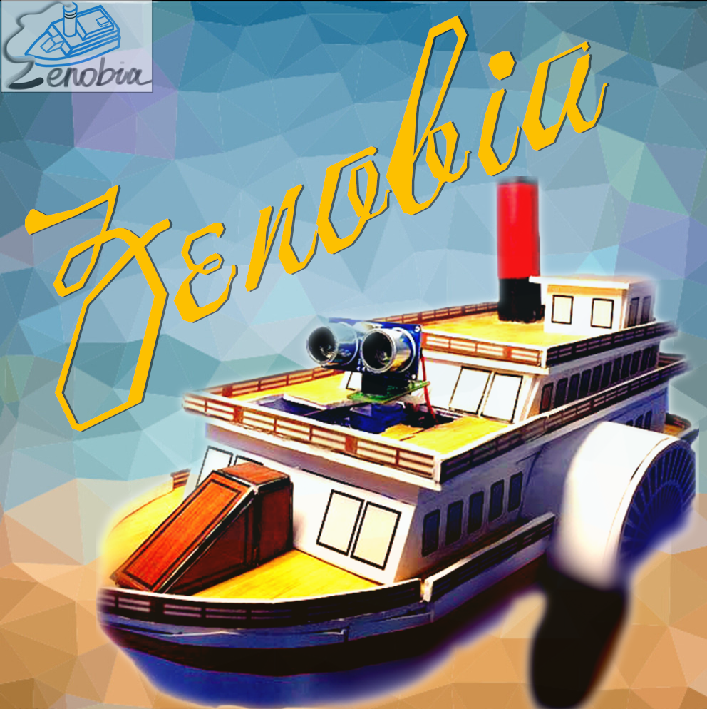

Group 31

September 21th, 2017

**Team Members**

|  |  |  |  |
| --- | --- | --- | --- |
| Name | Route Name | QMUL Student ID | BUPT Student ID |
| ZhiChao Qiu | Telecommunications Engineering with Management | 151009413 | 2015212945 |
| Shuhang Li | Telecommunications Engineering with Management | 151009217 | 2015212926 |
| Tianze Liang | Telecommunications Engineering with Management | 151008450 | 2015212852 |
| Zhongjie Luo | Telecommunications Engineering with Management | 151010981 | 2015213098 |
| Yidan Xu | Telecommunications Engineering with Management | 151009044 | 2015212909 |
| Kanjia Jin | Internet of Things Engineering | 151006571 | 2015213385 |
| Yifan Yuan | Internet of Things Engineering | 151006353 | 2015213364 |
| Minfeng Xu | Internet of Things Engineering | 151007176 | 2015213444 |
| Ruyu Yao | e-Commerce Engineering with Law | 151012893 | 2015213283 |
| Ran Mao | e-Commerce Engineering with Law | 151013281 | 2015213322 |
| Han Xu | e-Commerce Engineering with Law | 151012561 | 2015213250 |

**Introduction**

Zenobia is a drawing robot with extended functions. It is based on one Integrated circuit, a demonstration board and other functional modules. Zenobia has four main functions: remote control movement, drawing several basic geometric shapes, avoiding obstacle and mobile phone operation function. To achieve these functions, we use peripheral equipment such as Bluetooth modules, buzzers, remote controls, etc. At the same time, we also design a delicate appearance for it. In addition to the product, in order to extend all of Zenobia's charm to the users, we have made a website, which is a general e-commerce enterprise website. Our website has strong database support to protect the security and stability of shopping. We hope it can allow visitors to shop comfortably. At last, we have produced a poster to show the shape and beauty of the Zenobia.

**Contents**

**1. Product Design and Development ---------------------------------------------- 5**

1.1 Product Positioning ---------------------------------------------------------- 5

1.2 Logical Designing and Programming --------------------------------------- 6

1.3 Monolithic Integral Circuit and Peripheral Equipment --------------------- 12

1.4 Appearance Designing and Production -------------------------------------21

1.4.1 Design Thought ------------------------------------------------------ 21

1.5 Planning and Management ------------------------------------------------- 23

1.6 Website ---------------------------------------------------------------------- 24

1.7 Database -------------------------------------------------------------------- 24

1. **Design Choices------------------------------------------------------------------ 25**

2.1 Overall Appearance --------------------------------------------------------- 25

2.2 Micro Control Unit ---------------------------------------------------------- 25

2.3 Function Implementation --------------------------------------------------- 27

2.4 Website ---------------------------------------------------------------------- 30

2.5 Database ---------------------------------------------------------------------40

1. **Planning and Management ---------------------------------------------------- 42**

3.1 Time Planning --------------------------------------------------------------- 42

3.2 Team Meeting --------------------------------------------------------------- 42

1. **Reflection and Communication ------------------------------------------------ 44**

4.1 Design ----------------------------------------------------------------------- 44

4.2 Manufacturing -------------------------------------------------------------- 44

4.3 Draw AutoCAD Pictures ----------------------------------------------------- 44

**5. Advertisement Creative -------------------------------------------------------- 47**

**1.Product Design and Development**

**1.1 Product Positioning**

The name of our product is Zenobia, a drawing robot used as a gift. We all know that there are thousands of different types of drawing robots on the market. But the product we make is not only for drawing operations, but also for a beautiful decoration. This is where we are different from other products.

The appearance of the Zenobia was a steamship in industrial era. You can control the route by a special remote control attached to it and it will“sail”as you wish. If you choose to draw graphics, it will leave the track of graphics you choose in the process of "navigation" (remember to keep the car on the large enough paper, otherwise your floor will become the No. Zenobia’s drawing board). Of course, you can also download a dedicated cell phone App to operate it via bluetooth.

When your guest praises a steamship model on your shelf, who can know it is a fully functional drawing robot?

**1.2 Logical Designing and Programming**

● **Bluetooth mode**

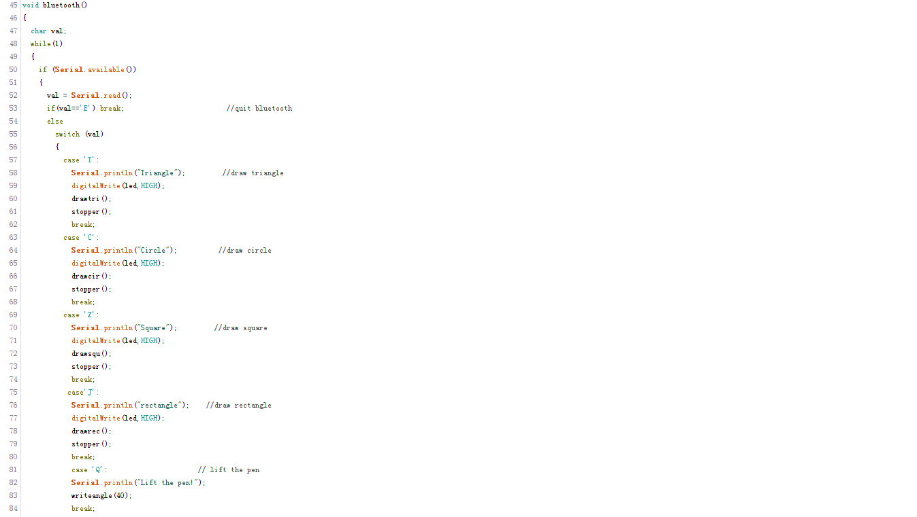

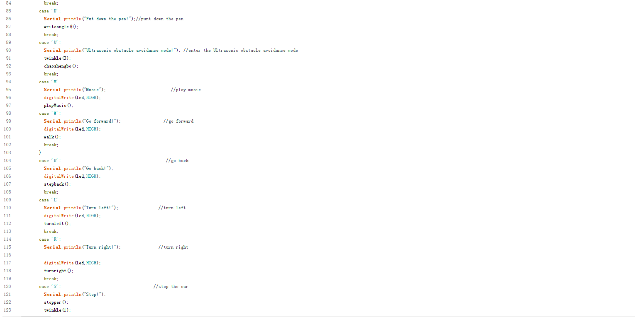

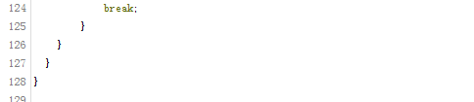

● **The buzzer plays music**

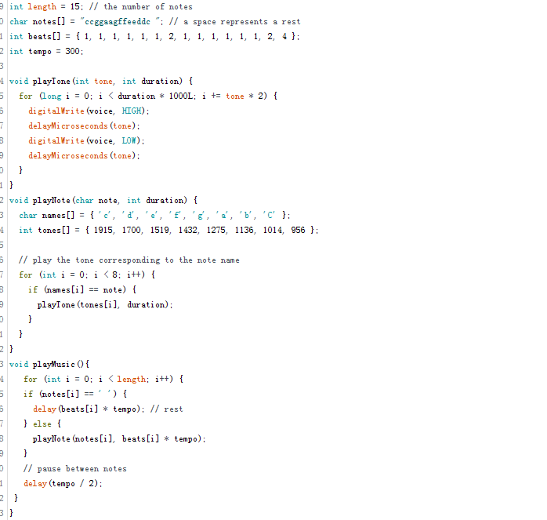

● **Control the steering gear**

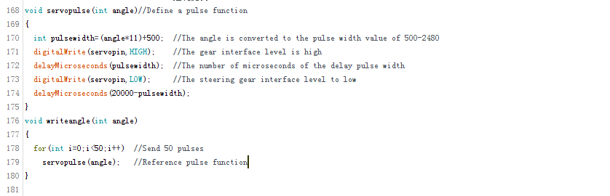

● **Car movement**

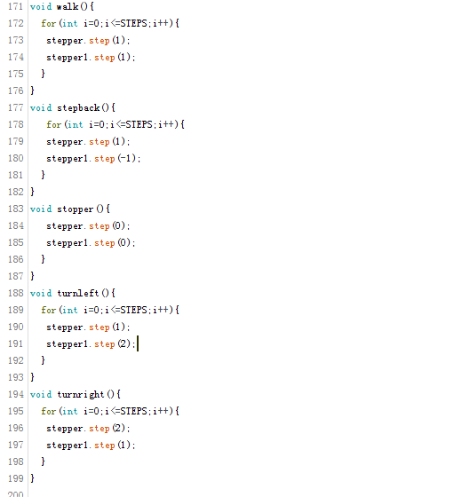

● **Car drawing**

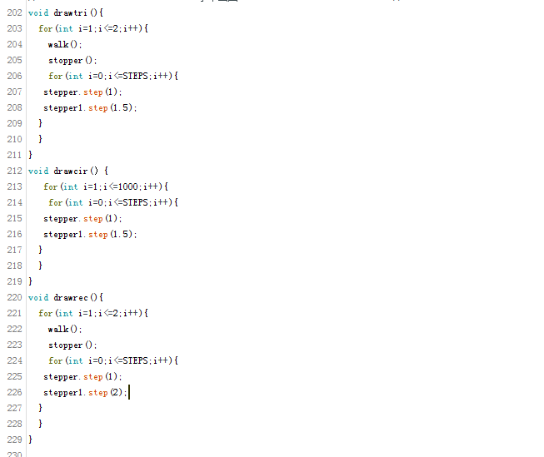

● **The buzzer warning**

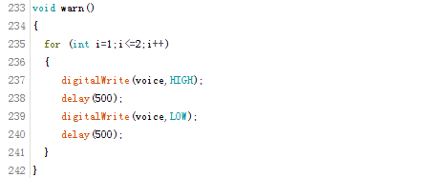

● **LED flashing**

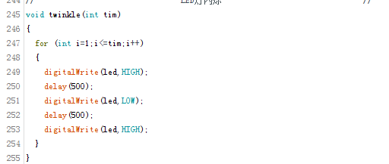

● **Ultrasonic obstruction**

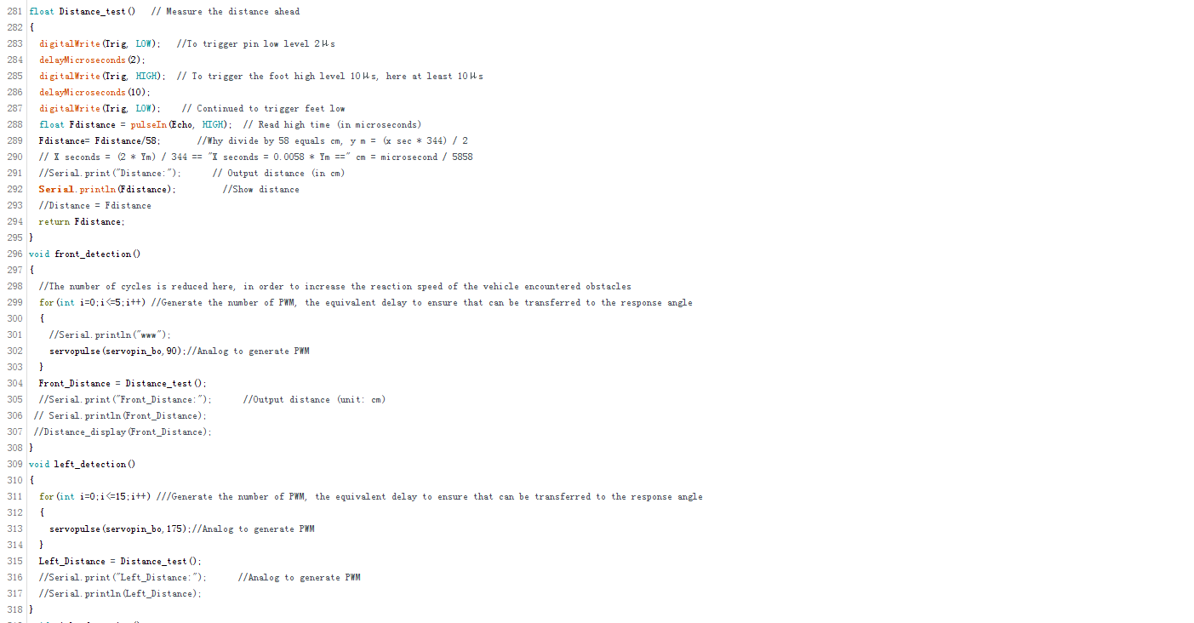

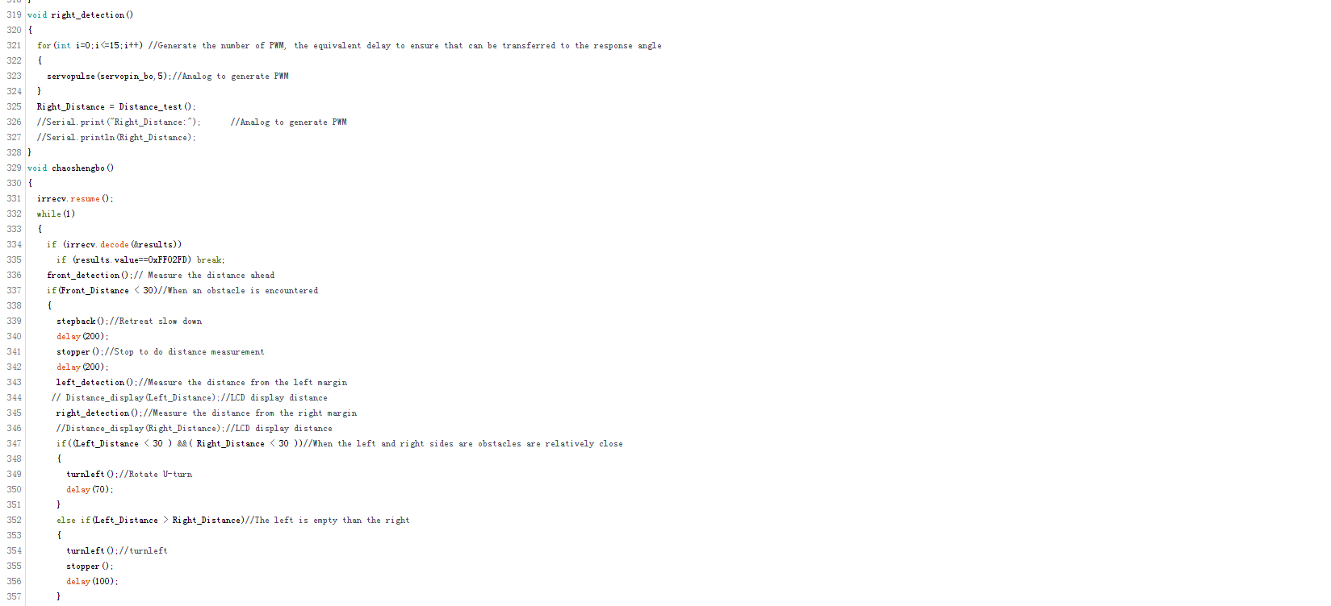

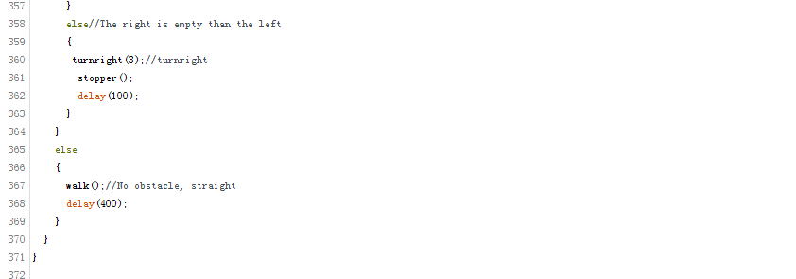

● **Infrared control**



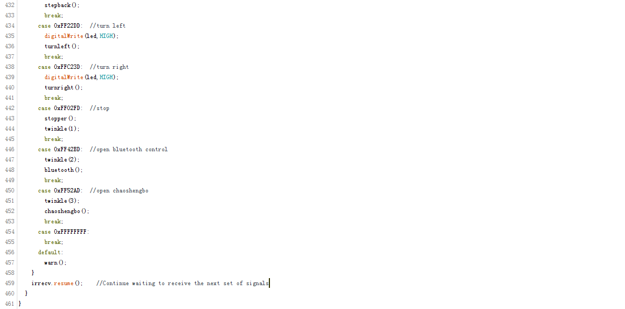

**1.3 Monolithic Integral Circuit and Peripheral Equipment**

We use Arduino Uno board as the control module. According to arduino code, we decide different input and output to the motor to achieve the purpose of moving and drawing.

In this process, we learned and used Proteus and Protel to connect the motor. We connect the steering gear with sensors and drivers. Finally we realize all of the basic functions. As shown in the following figure:

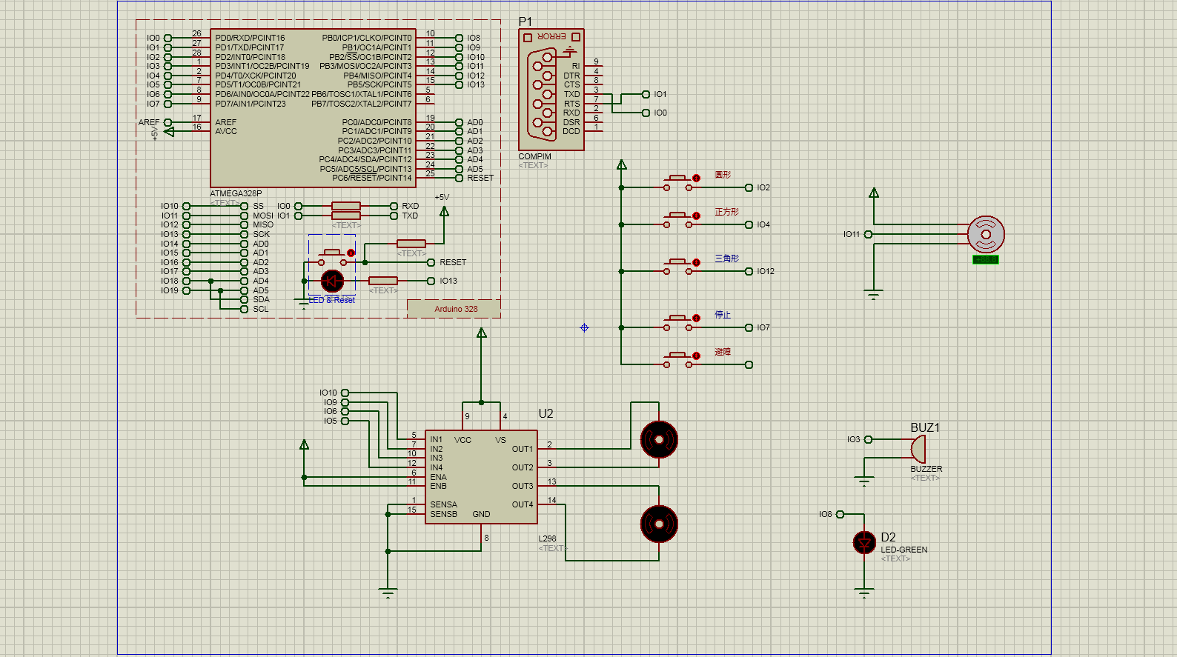

(Because of the software, some sensors cannot be used directly. So we choose other devices instead and the overall function can still be achieved)

For the constraints of the interface, we input the signal from the button and only set up the basic action. When we press the circle, IO2 will receive a high level. After encoding, two motors will receive different signals and change in different degrees. IO11 will rotate a certain amplitude and cycle back to the original point of view, while buzzer and LED will change accordingly. At the end of the process, the paper will get a fine round. Accordingly, if the square is pressed, the IO4 will accept a high level, and the UNO board will process the signal correctly making the image drown.Identically, if you press the triangle, IO12 will accept a high level, and the UNO board will control the motor driving reasonably. If you press stop, IO7 will accept a high level,which means all motors will receive high potential making the motor stop and the car stop. Other functions are not shown in the simulation interface due to limited interface. But the basic principle is same, so you can complete rest of functions of the car according to this map.

● **Motor drive module**

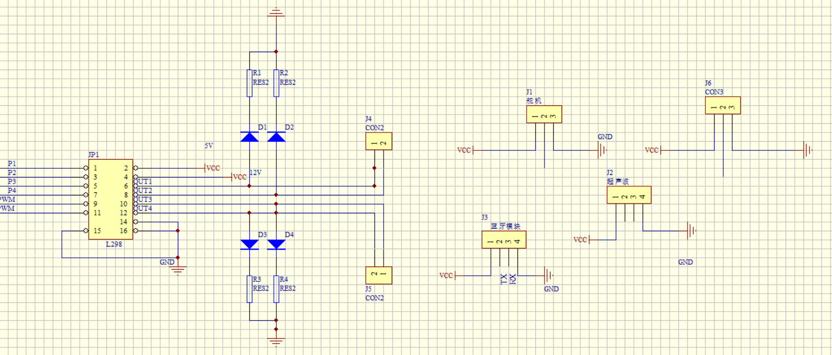

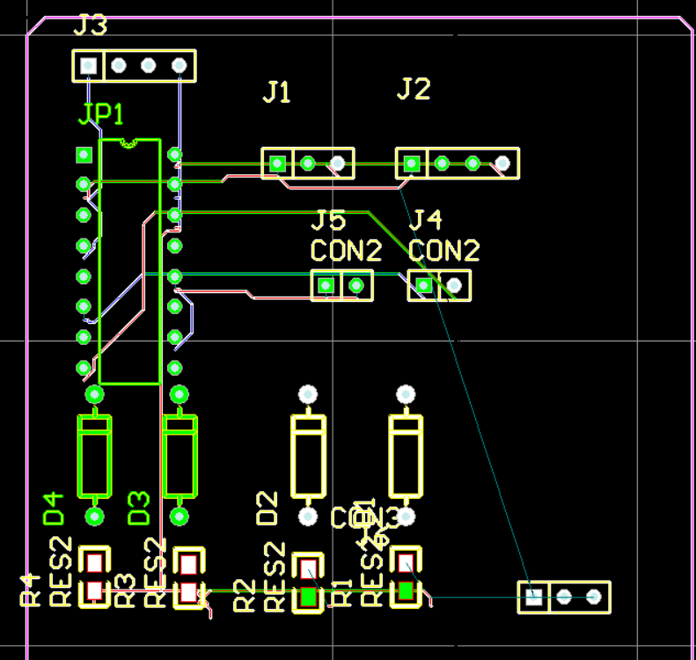

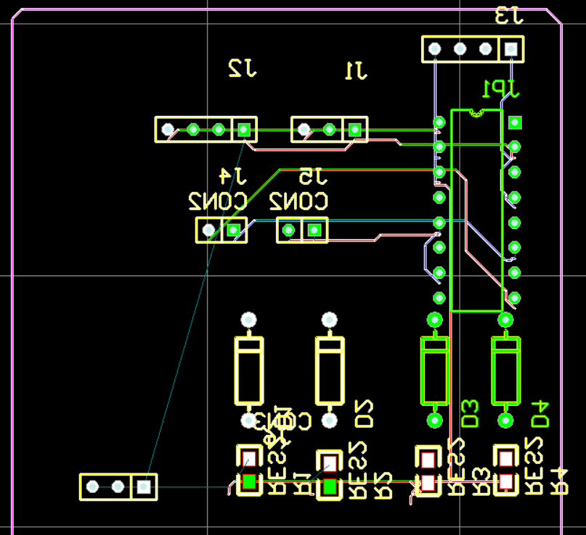

● **Power supply system**

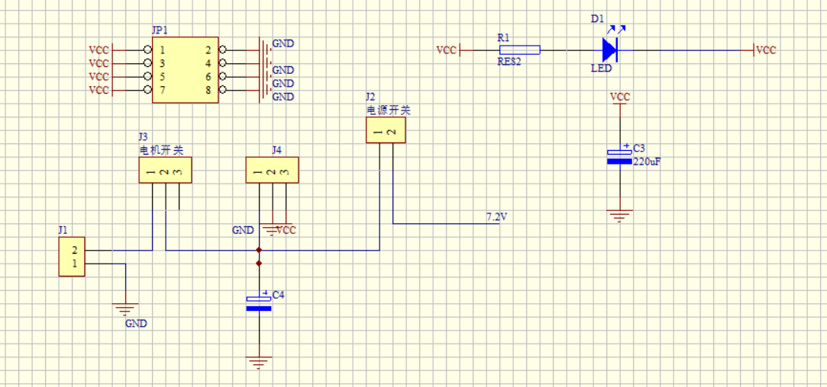

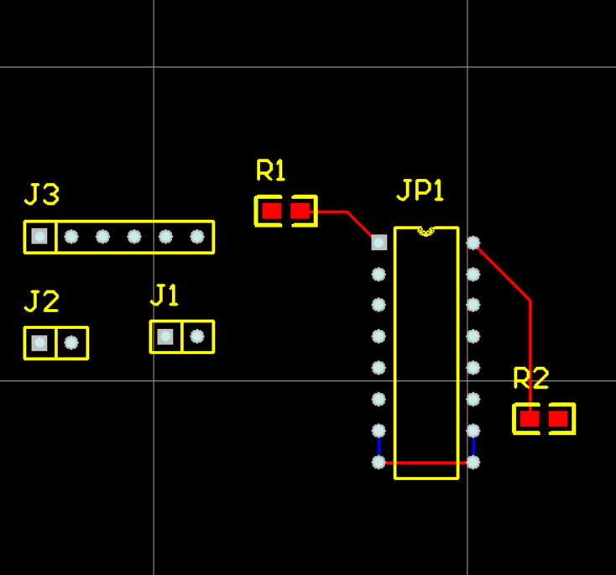

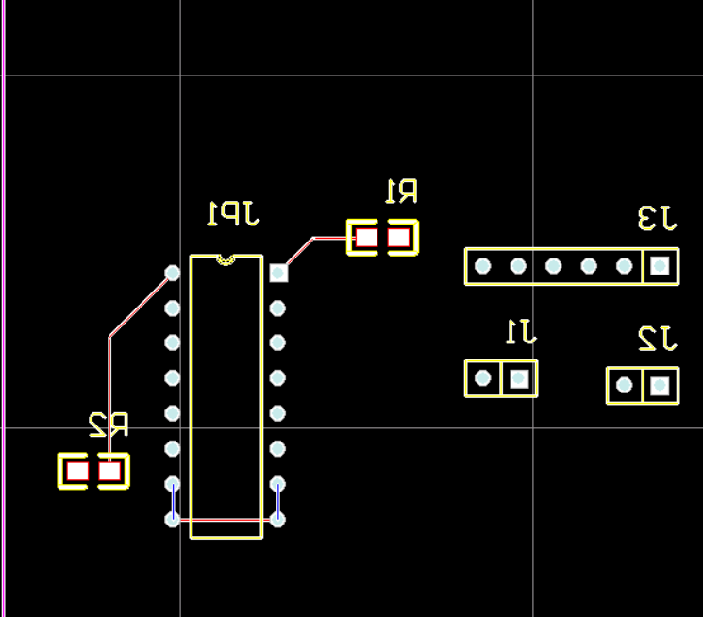

● **Infrared sensor module**

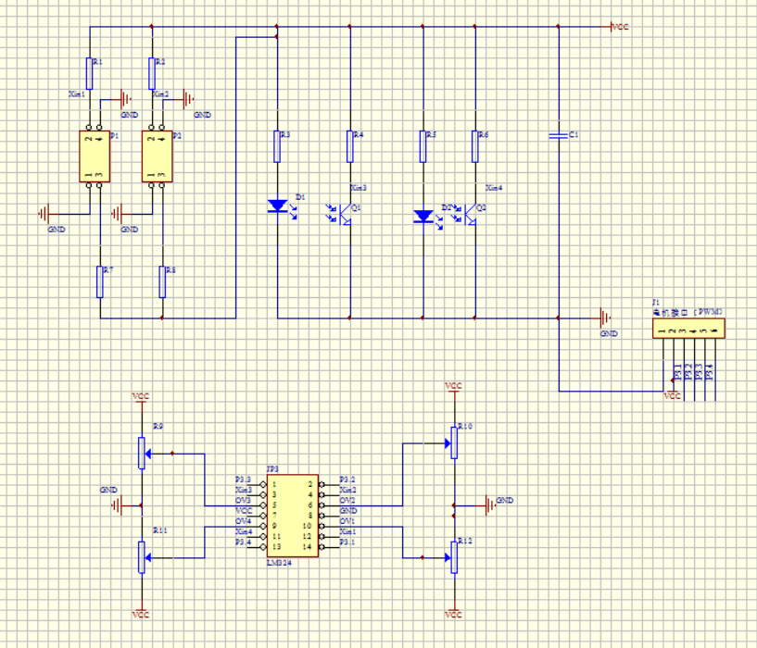

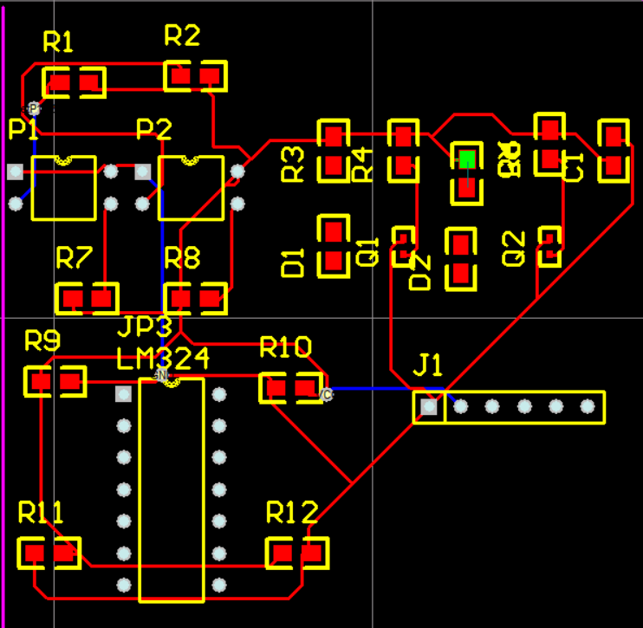

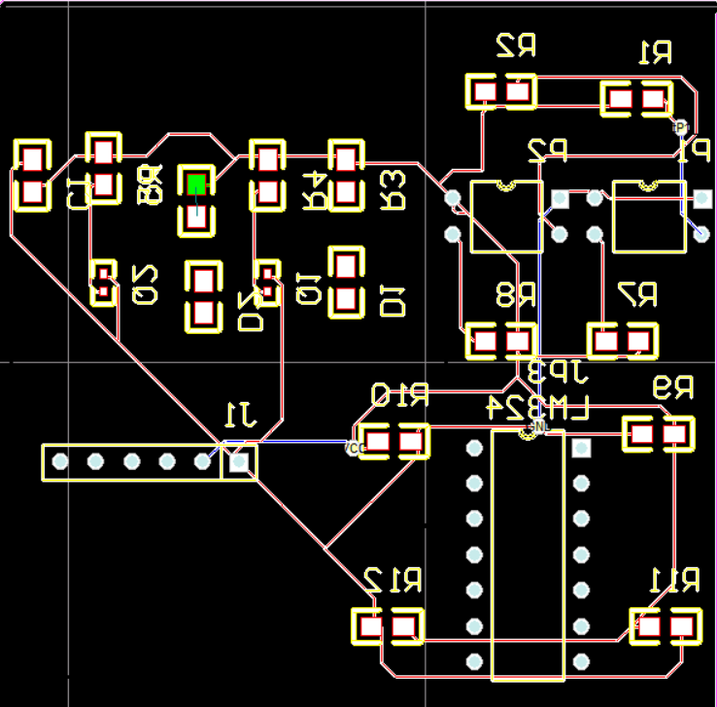

**1.4 Appearance Designing and Production**

**1.4.1 Design Thought**

For the design of product , we focus on several main aspects:

● **Material selection**

In order to ensure the drawing function of the robot can keep stable in a long time and reduce unnecessary power loss. The Zenobia Design Group takes product portability into account when we consider the choice of materials. At the beginning, we chose the thin wood. But then we found that its weight and hardness exceeded our expectations. After a period of research, we found a lighter, plastic chevron board as the main material to make the shell. In addition, we use printing coated paper to make delicate appearance.The shell’s portability ensures that the drawing robot does not produce unnecessary waste of electricity due to the influence of weight. It’s also convenient and safe for young users to play.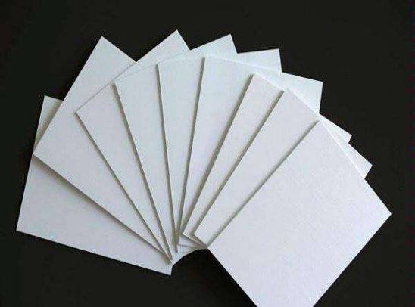

● **Creative**

After a detailed discussion among the members of group, we made a decision. First of all, we plan to target it as a beautiful gift. Next, we believe that the interior structure of the car can perfectly fit with the appearance of the steamship in the industrial age. Then we built a preliminary design picture using CAD and we adjust it according to the actual function. We designed the electric indicator light in the captain's room, set the horn in the whistle position, which made the appearance of the steam boat closer to reality and reflect the romantic feeling of steam punk in the industrial age.

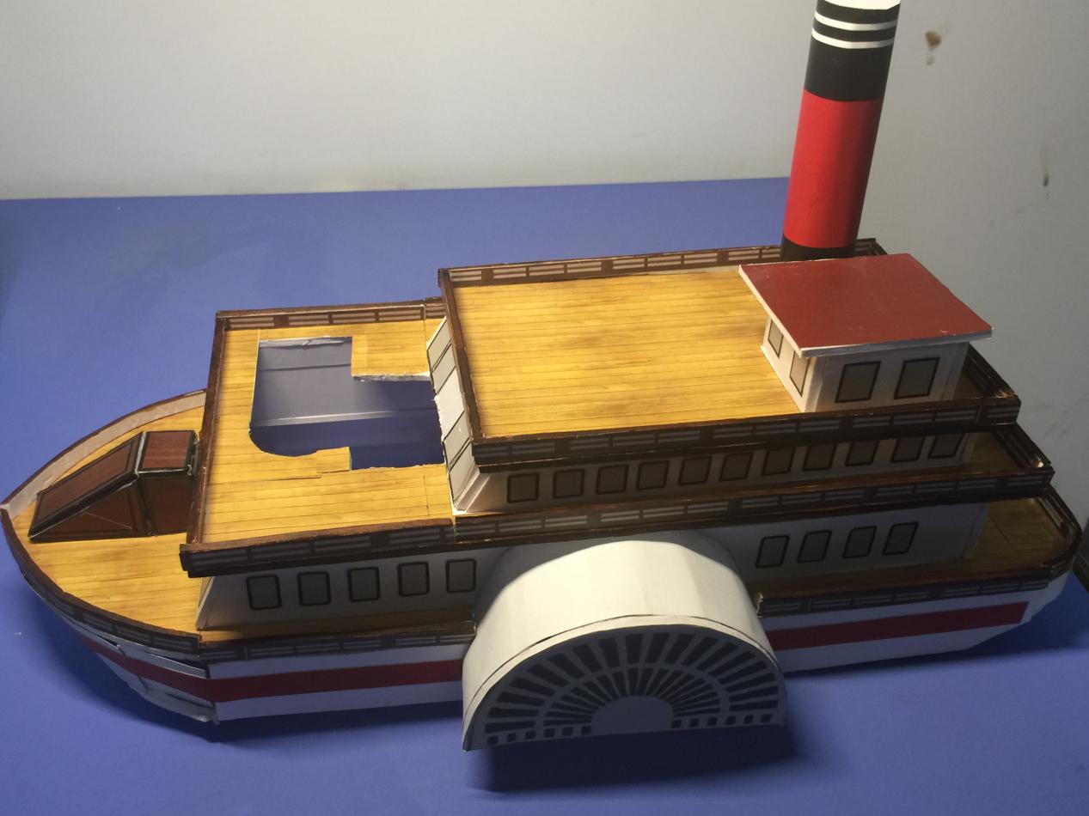

What’s more, when we take different functions of this robot into account at first, we don’t think that this robot should only finish the basic function given by school. It should do something that a real car and robot can do. After discussion and question, our team determine to add some new functions as our team’s innovation, such as bluetooth control, obstacle avoidance.

**1.5 Planning and Management**

This task is completed by the telecommunications engineering and management, E-commerce and law, Internet of Things three professional students to complete. After several meetings, we decided the division of labor. Tem students construct the robot; Ecl and Iot students complete the contents of the site and the database.

After our first group meeting in July 6th, we identify our team division. We identify two leaders for each major so that teamwork can be carried out effectively. In each major, we have a clear division of labor. What’s more, we also identify the deadline for each task so that tasks can be completed on time. Between different majors, we have online WeChat meetings in summer vacation so that we can determine the work progress and work planning. Finally, we finish this report in cooperation. We can say that the ongoing communication and identified division are the basis of the success of this whole teamwork.

**1.6 Website**

The website of robots is a general e-commerce enterprise website whose main function is to allow users to understand and purchase robots. The website has strong database support to protect the shopping safety and stability. By displaying the list of products, we believe that the customer would be interested

**1.7 Database**

To support the various data both generated and required by the website, databases should be established. A database is a large organized collection of data organized for rapid search and retrieval. We use MySQL as the database management system to interact with the website.

**2. Design Choices**

**2.1 Overall Appearance**

Considering the demand for gifts or teaching, this product conforms to the concept of light and easy-controlled as much as possible. Thus, we use the chevron board shell. At the same time, we provide Bluetooth and infrared two control methods.

**2.2 Micro Control Unit**

Arduino Uno is a micro controller board based on the ATmega328P (datasheet). It has 14 digital input/output pins (of which 6 can be used as PWM outputs), 6 analog inputs, a 16 MHz quartz crystal, a USB connection, a power jack, an ICSP header and a reset button. It contains everything needed to support the micro controller; simply connect it to a computer with a USB cable or power it with a AC-to-DC adapter or battery to get started.

******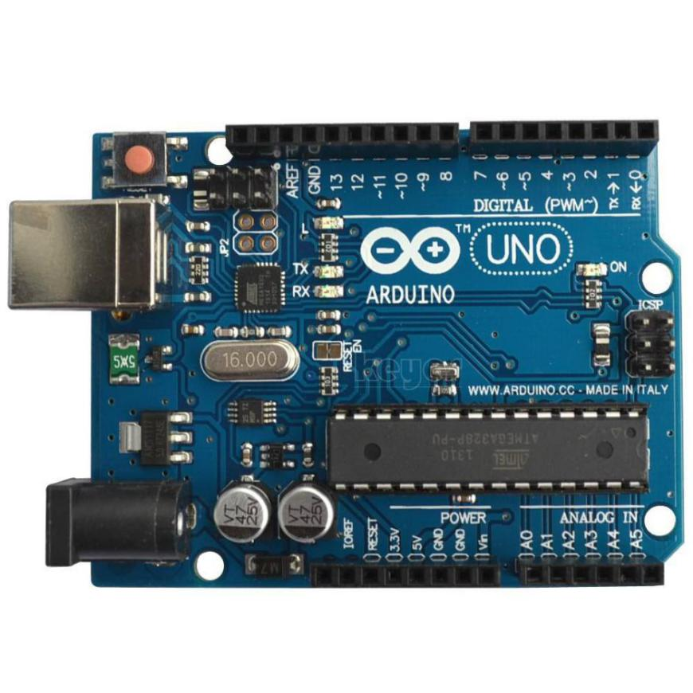**

**2.3 Function Implementation**

The preferred features of the Zenobia are as follows:

● **Remote control function**

The user can operate the Zenobia by using a dedicated remote controller, or by means of an exclusive mobile App. The user can control it to move forward, backward, turn left, turn right, draw graphics, and so on.

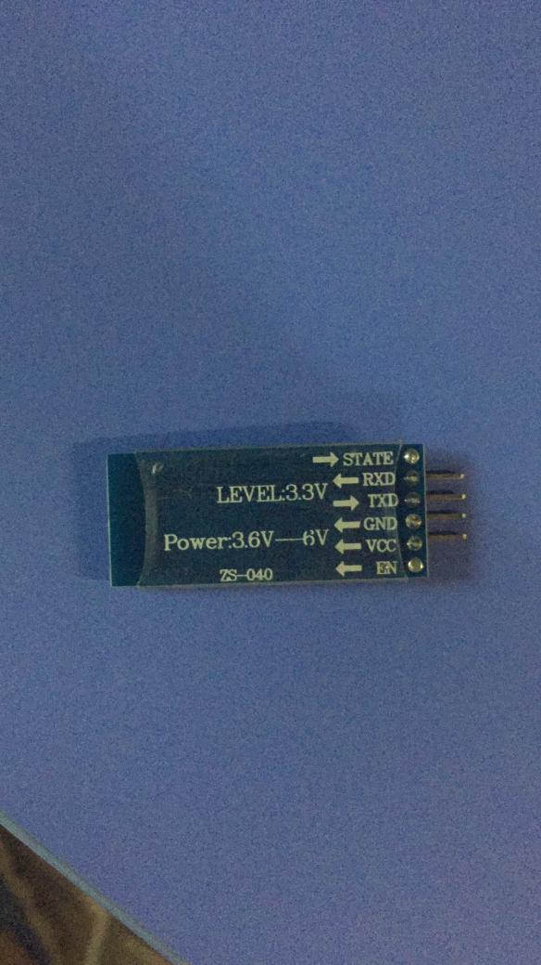

● **Drawing function**

Once the drawing instruction is received, the Zenobia will execute the instruction for plotting until the drawing is done.

● **Obstacle avoidance function**

Zenobia has advanced ultrasonic obstacle avoidance capabilities. And if obstacles are encountered during the progress, the Zenobia will determine the space on the left and right of the obstacle and turn to a larger direction. If an obstacle is encountered during drawing, the Zenobia will stop drawing automatically.

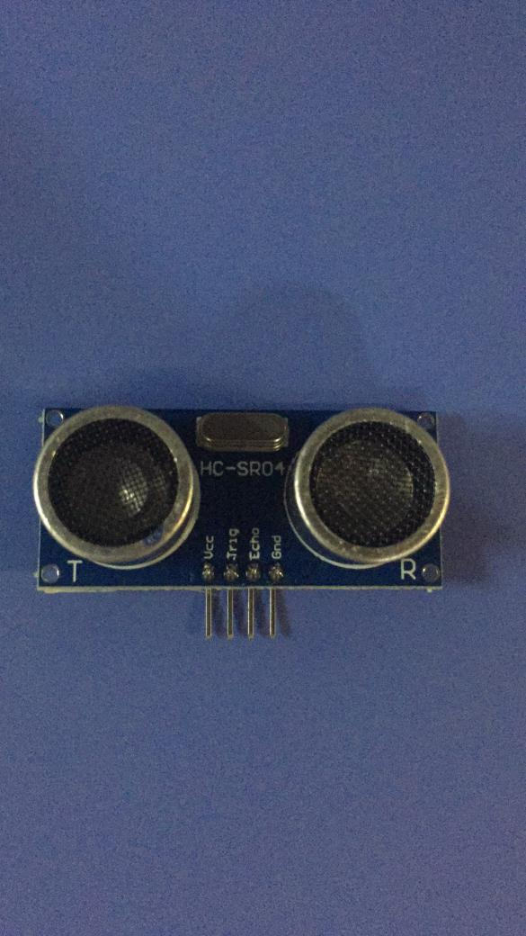

● **Whistle function**

The Zenobia can mimic the steam boat siren sounds and users can operate via the remote control or cell phone App.

In addition, we consider four aspects in the design and manufacturing process:

● **Appearance**

Since the Zenobia is designated as a gift, its exquisite appearance requires it to occupy a space in the living room and attract guests' attention.

● **Security**

As an ornament with special functions, it also needs strong stability. So we use a strong and durable chevron board as the basic material to make the shell.

● **Convenience**

We use a lightweight material to make the shell, which is easy to carry. In addition, we also provide users with two ways to control the car (infrared control and Bluetooth control).

● **Stability**

We use the stable stepper motor instead of DC motor, so that the car can be more stable in drawing and will not draw a large deviation of the graphics.

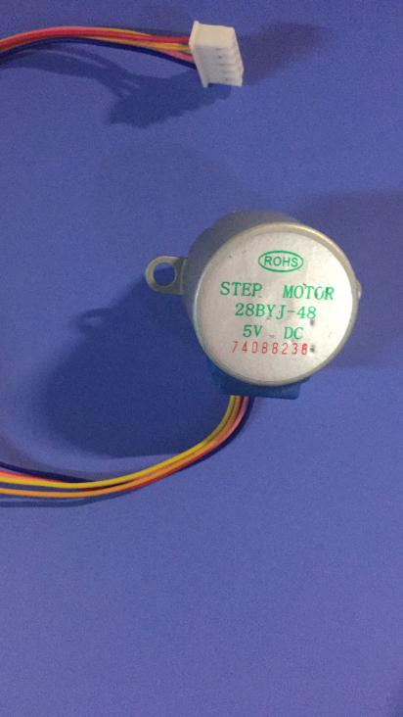

**2.4 Website**

● **Home page**

At the beginning stage of the website design, we confirm some fundamental functions that customers may expect, like viewing product details. We hope that our website could make visitors feel relaxed and comfortable while shopping, compared to some other sites such as shopping sites. So we use the dark blue scheme to give visitors a sense of visual impact but not complicated. And the home pictures can be automatically converted to ensure that the page aesthetics and the ease of operation.

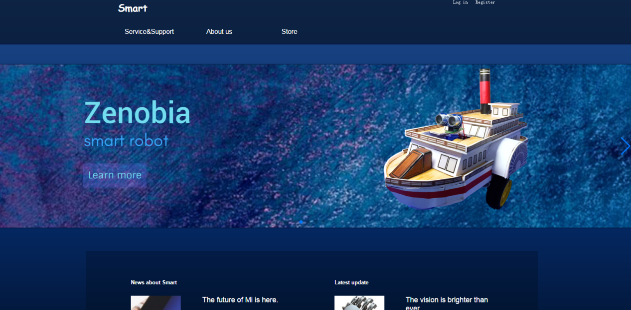

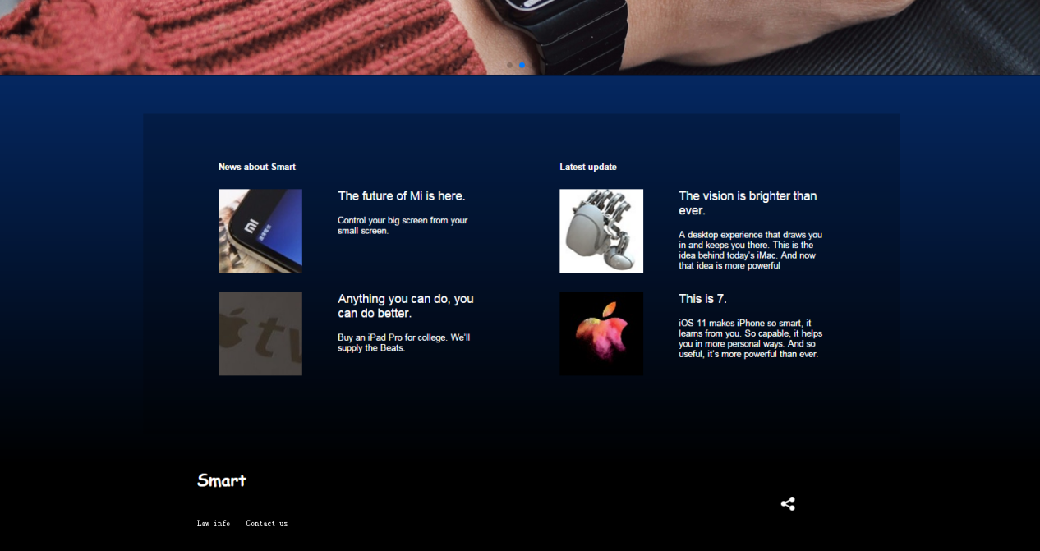

What's more, we provide services&support to introduce some practical skills and product warranty services. We also provide the company information in order to deepen the user's understanding of us.

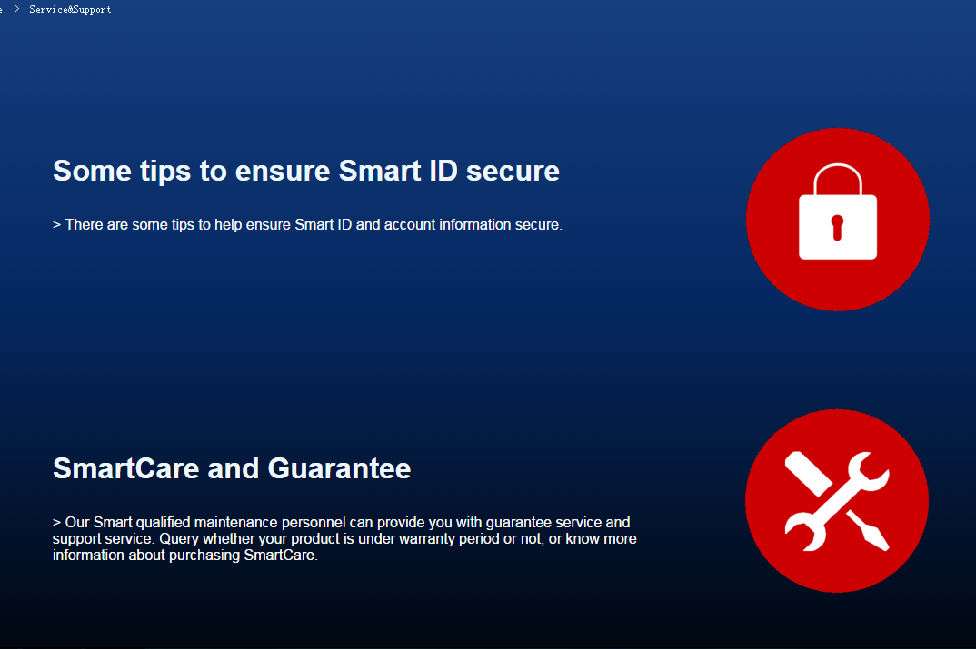

● **Register**

Customer could fill in the information blanks needed and our database would store and protect the information, in case of their information loss. 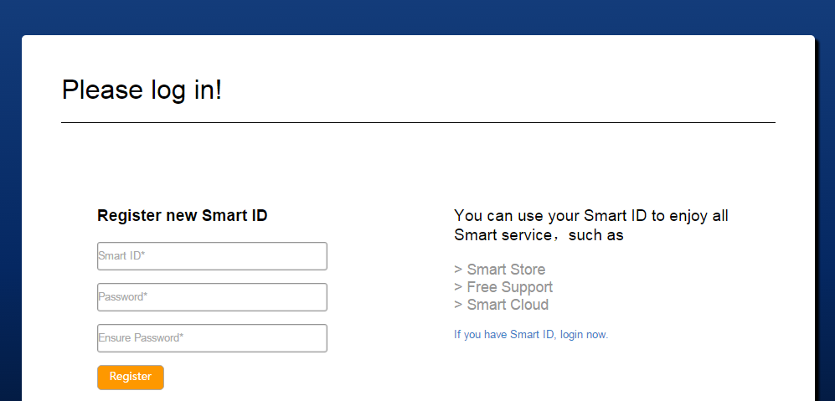And our registration provides password verification in order to ensure the accuracy of user’s information. After successfully registered, three seconds later it automatically skips to the login page.

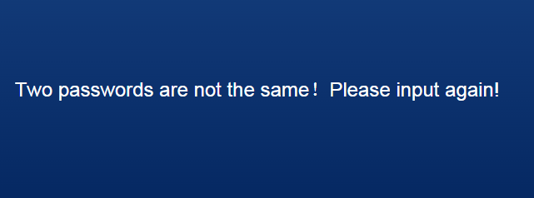

● **Log in**

As long as the customer has registered once, the website could identify the username. If the code and name matches in database, customer would log in successfully. If not, the website will remind the customer to login or register. After successfully logged in, it would automatically skip to the home page.

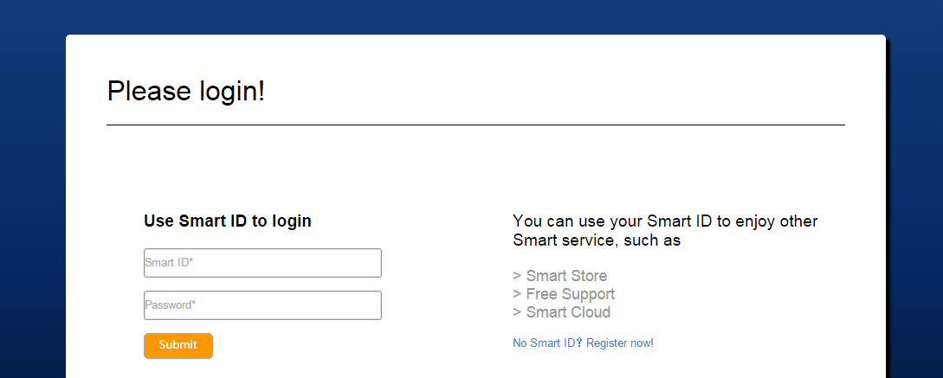

● **Product List**

By making a connection with database, we can achieve the function of displaying products list by clicking ‘store’.

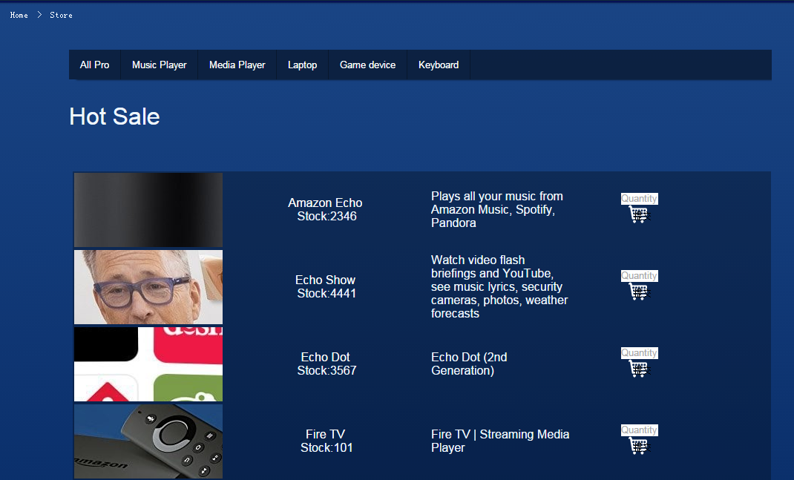

Also, the user can click the product name to view the product details.

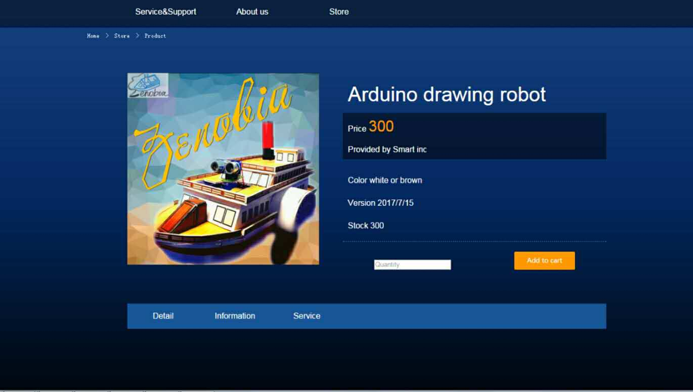

If the customer is out of log, he could view the details of the product but can not add it to the cart. When the users clicks to ‘Add to cart’, the page will automatically skip to the login page and ask the users to log in again.

If the customer has logged in, he could view the details of the product. Also, they can modify the number of purchases and add the products to the cart.

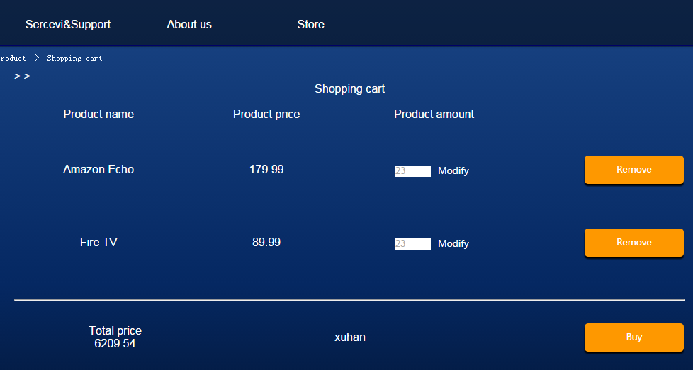

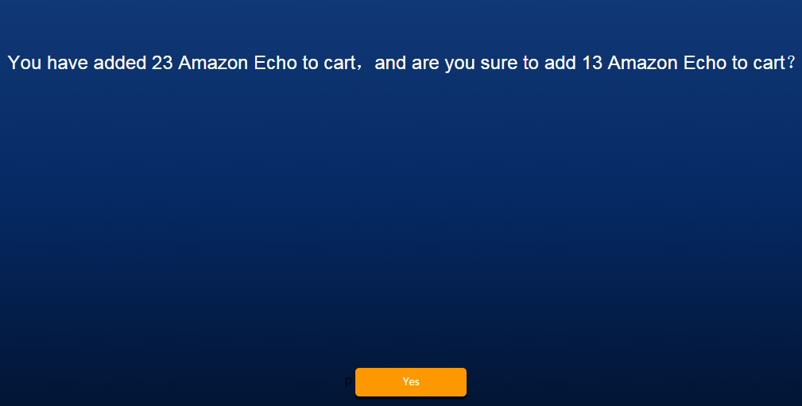



**● Product search**

For the convenience of users, the website provide the automatic search function in the upper right corner of the page. Users can enter the product name in the blank to search for the products they want.

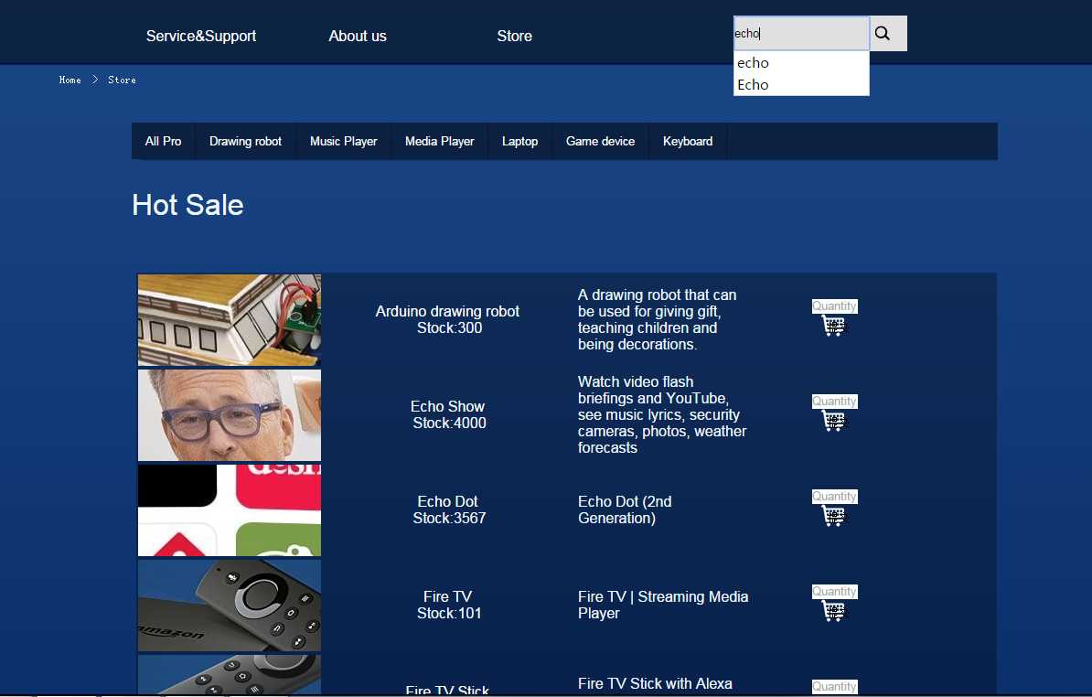

● **Shopping cart**

After logging in, by clicking the ‘Add to cart’ button, customers can see the products that they are intended to buy and alter, delete or add them in Shopping cart.

The users can click ‘remove’ to delete the products they don’t want to buy.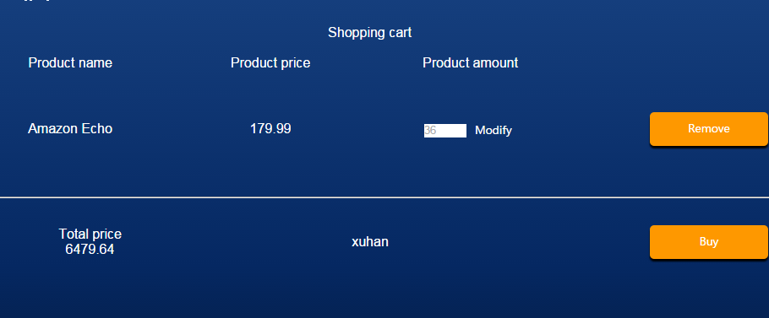

Our web page will automatically calculate the total amount of consumption. Customers could click ‘buy’ to submit the order.

● **Prompt**

After customers submitted their order, they could get this prompt page to fill in the order information, such as the recipient's name, shopping address and user phone number. After it, they can click ‘order’ to submit the information.

In this page, the users can see the total price of the products they have bought.

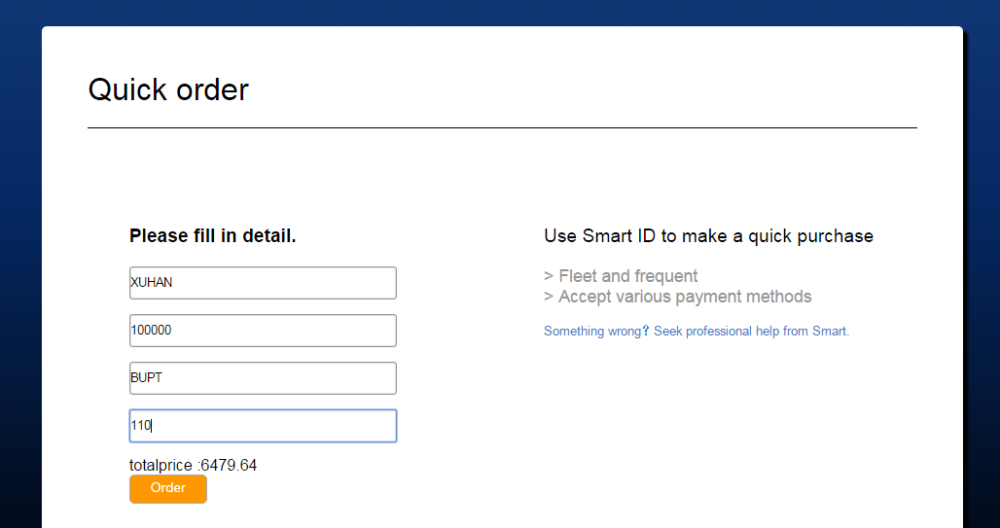

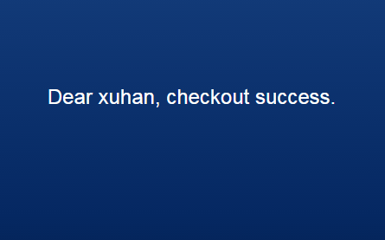

After the user completes the purchase, the product selected by the user will be cleared and the quantity of the product will be automatically reduced.

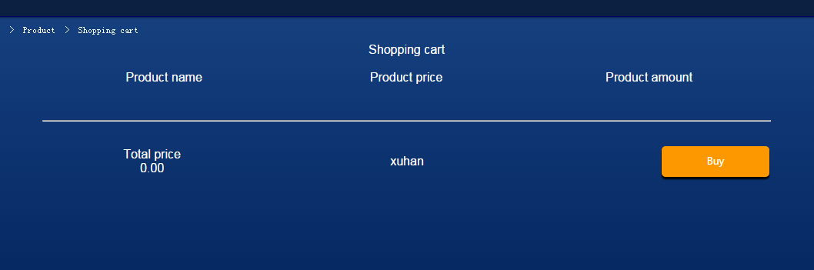

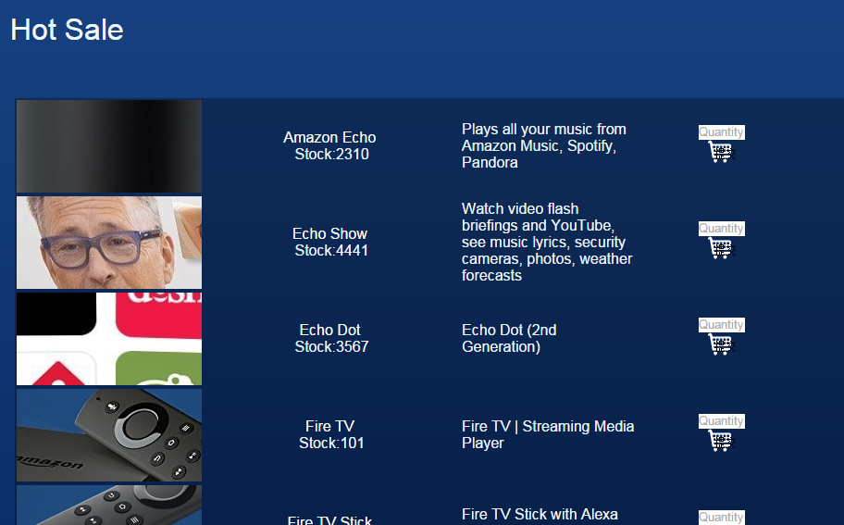

● **Introduction of our team**

Customer can see the introduction of our company and our team by clicking “About Us’.

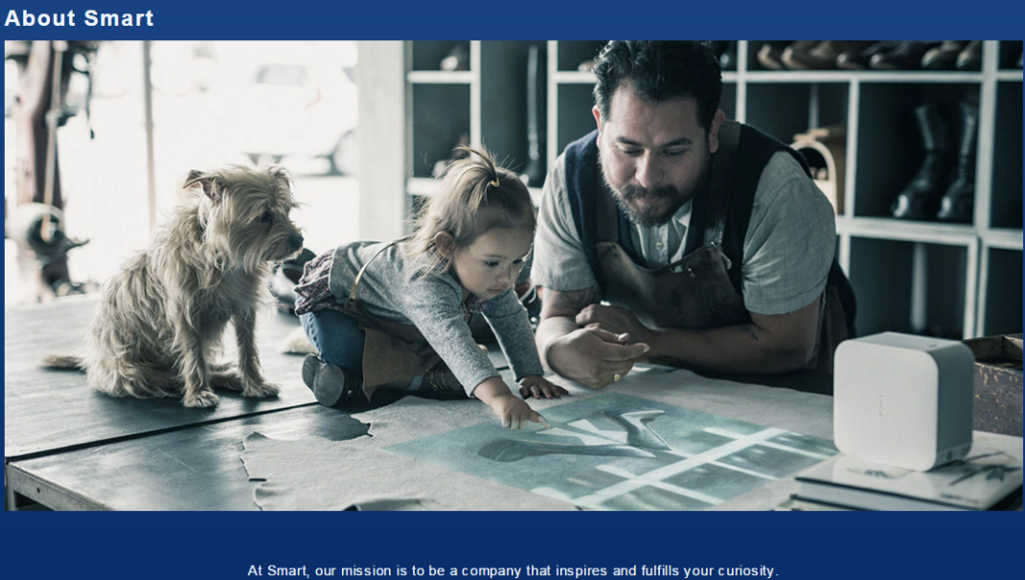

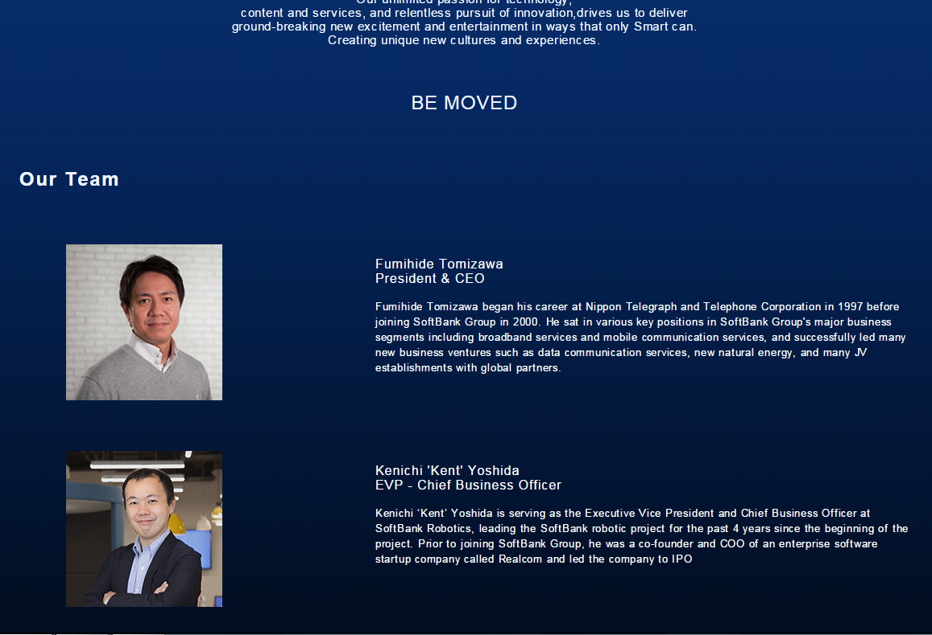

**2.5 Database**

We have a total of four databases to support the operation of our website, namely B_order, Cartlist, Productlist and Userinfo.

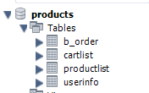

● **Userinfo:** Used to store the information that the user has filled in when they are registered.

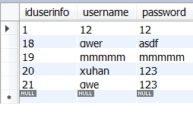

● **Productlist:** Used to store product information. The information will be displayed when the user clicks on the product name.

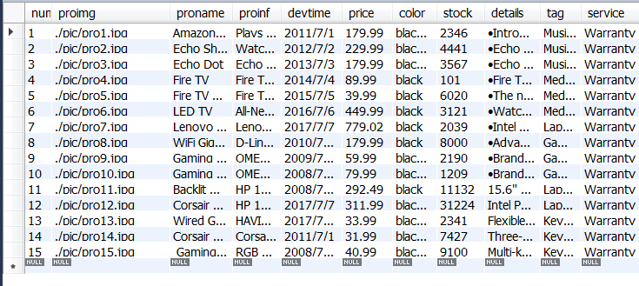

● **Cartlist:** Used to store information that the user adds the product to the shopping cart.

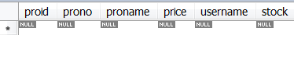

● **B_order:** Used to save the order information entered by the user after the ‘submit’ is clicked.

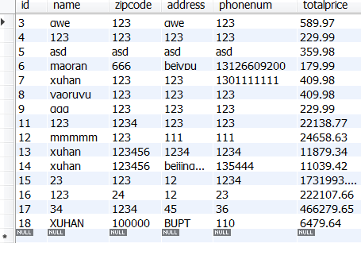

**3.Planning and Management**

**3.1 Time Planning**

|  |  |
| --- | --- |
| July 4th | Learning basic knowledge and circuit soldering. |
| July 5th | Learning about software usage and installation software (Proteus, CAD, PROTEL, Arduino). |
| July 6th | Assign tasks according to the workload (Zhichao Qiu and Zhongjie Luo are responsible for Proteus simulation, Tianze Liang is responsible for CAD, Shuhang Li is responsible for Protel, and Yidan Xu is responsible for Arduino). |
| July 7th | According to the assigned work, began to learn our own work. |
| July 8th-July 10th | Study and work for three days and exchange experience with each other. |
| July 11th | Our team went out to purchase the task material and began to make the appearance. |
| July 12th | Each task was completed. Start debugging and repairing small bug. |
| July 13th | Ask the teacher detailed questions about the project and continue debugging. |
| July 14th | Acceptance robot. |
| July 15th-September 15th | During the summer vacation, we studied related technical problems and exchange work progress. |
| September 16th  -September 21th | Complete the robot ,website and database. Write report and user manual. |

**3.2 Team Meeting:**

|  |  |
| --- | --- |
| **Time** | **Meeting content** |
| July 6th  30 minutes | The meeting set the theme of the product and website.We also elected three leaders for each major.What’s more,we clarify each member’s mission. |
| July 9th  20 minutes | Check the progress of each major. Share the progress and the doubt we meet. |
| July 13th  10minutes | Summing up the task. Ready for acceptance and the summer vacation mission.  Adjust the division of each member. |
| August 20th  20minutes | A WeChat conference, exchange the work progress and the work we have done in vacation. Prepare for the school season. |
| September 17th  15minutes | Summarize each member’s work. Start to write report and user manual. Prepare for the presentation in 26th. |

**4. Reflection and Communication**

**4.1.Design**

After determining the initial idea, we produced engineering drawings for Zenobia. In the designing process, we also faced many problems, like the lack of professional engineer design experience. So it took us a long time to search on the Internet and find answers in books that fit our design ideas. The drawings revised many times to meet teacher’s standards. Finally we did it.

**4.2 Manufacturing**

To put the integrated circuit board inside and protect it , the robot's shell must be thick enough, about 3-5mm.At the same time, it can not affect the wheels’ rotation. So we choose smooth chevron board to meet the requirements. A problem is the motor and the chassis are not fit. So we cover a layer of paste upon the chevron board on the top of the motor. Another problem is how to fix the shell. Finally we use a combination of mortise and tenon to make it stable on the chassis without affecting the circuit.

**4.3 Draw AutoCAD Pictures**

In fact, we haven't learned much about modeling before. Before starting modeling, we checked a number of related tutorials and books to see how to use it. We found that although CAD is not a good 3D modeling software, its full size setting function enables us to produce more accurate design model when designing. Although the final product was partially adjusted for the new functions that were temporarily added, the design of the CAD still made us very smooth.

The success of a product is never to blame for one person, but to the success of our entire team.

This is a screenshot of our CAD modeling

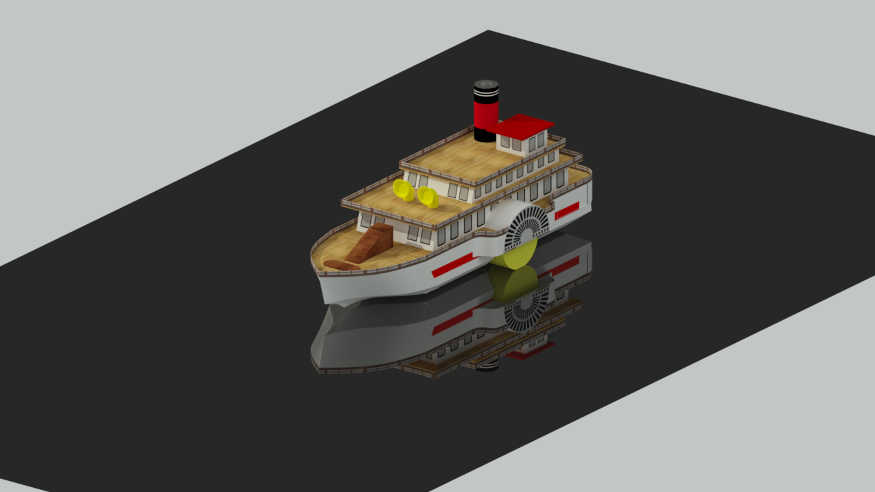

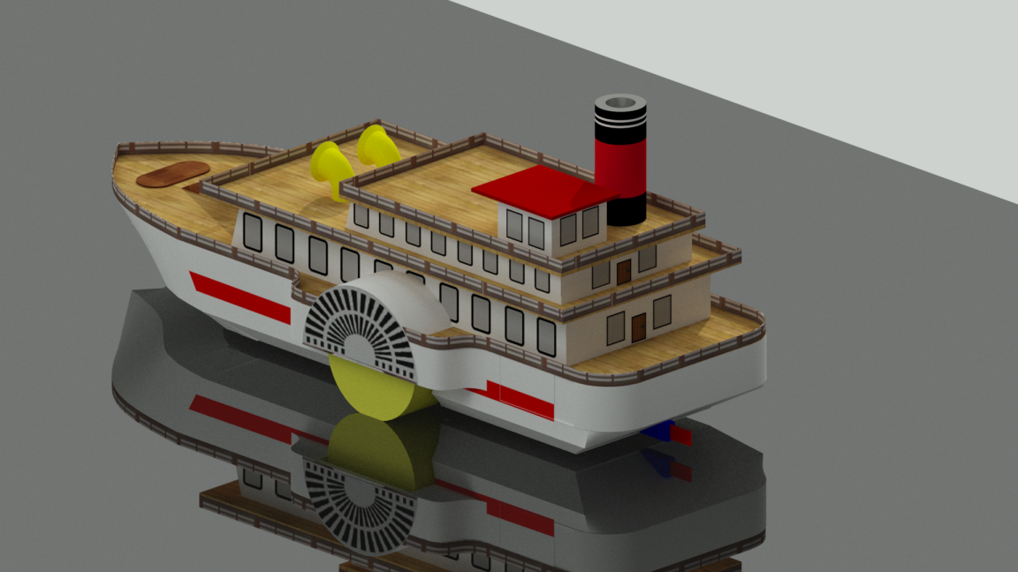

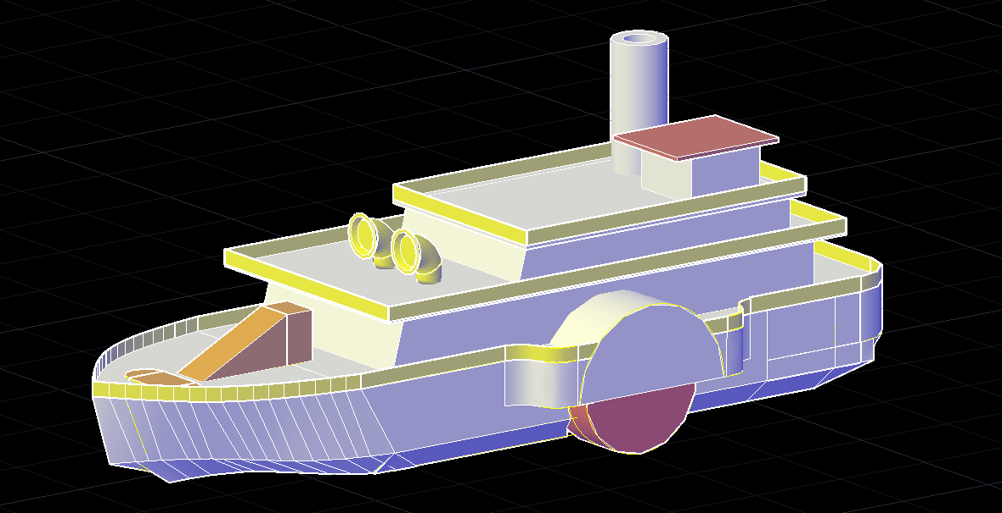

**5.Advertisement Creative**



This is our product poster. In order to attract the user's attention, we choose to use multiple colors to enhance the visual impact of the product and show the appearance and characteristics of our product. At the same time, the retro color will give the user a sense of intimacy and familiarity.